# AWS Budgets

Login to AWS Management Console and search for Billing and Cost Management.

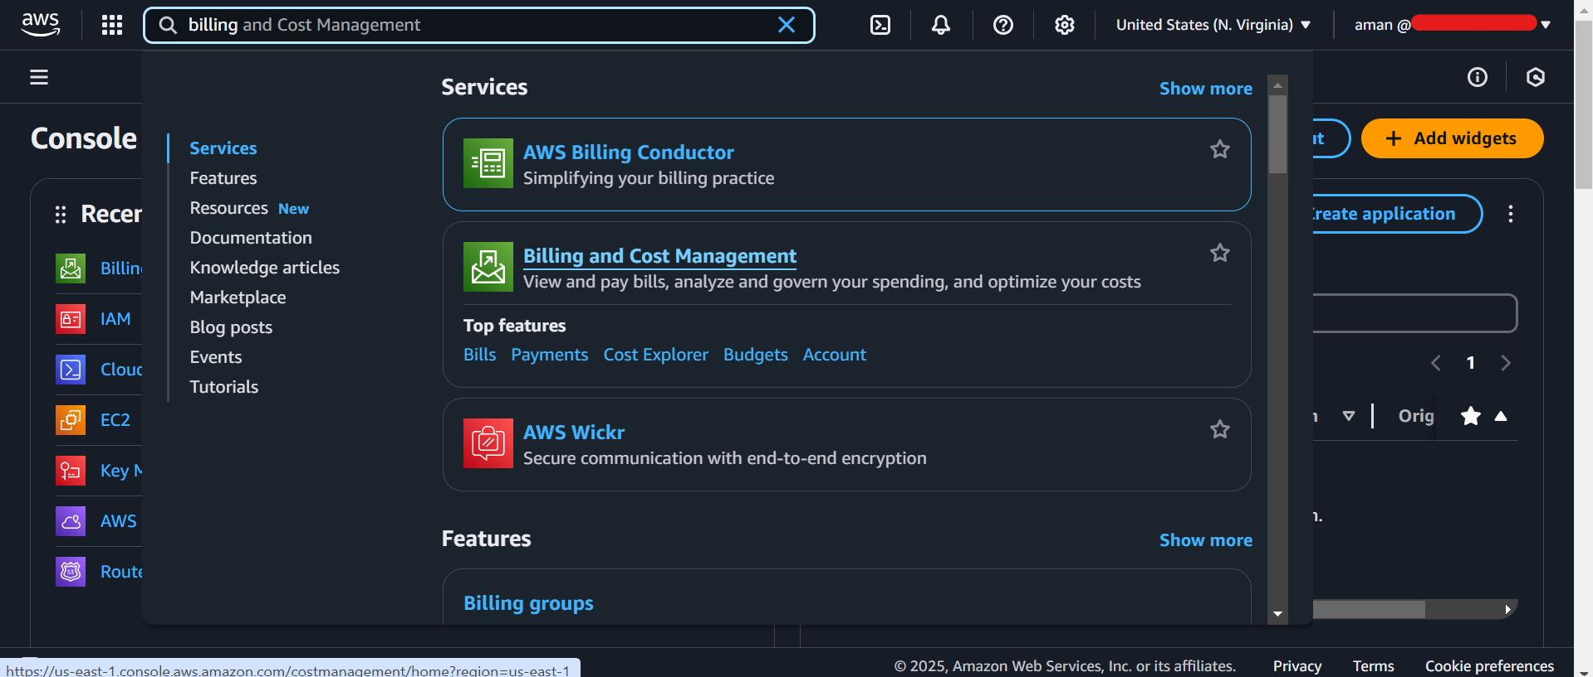

Find Budgets and click on it.

Click on “Create a Budget” button.

Choose the following (We are setting up a budget so we get notified if/when we incur our first $$$)

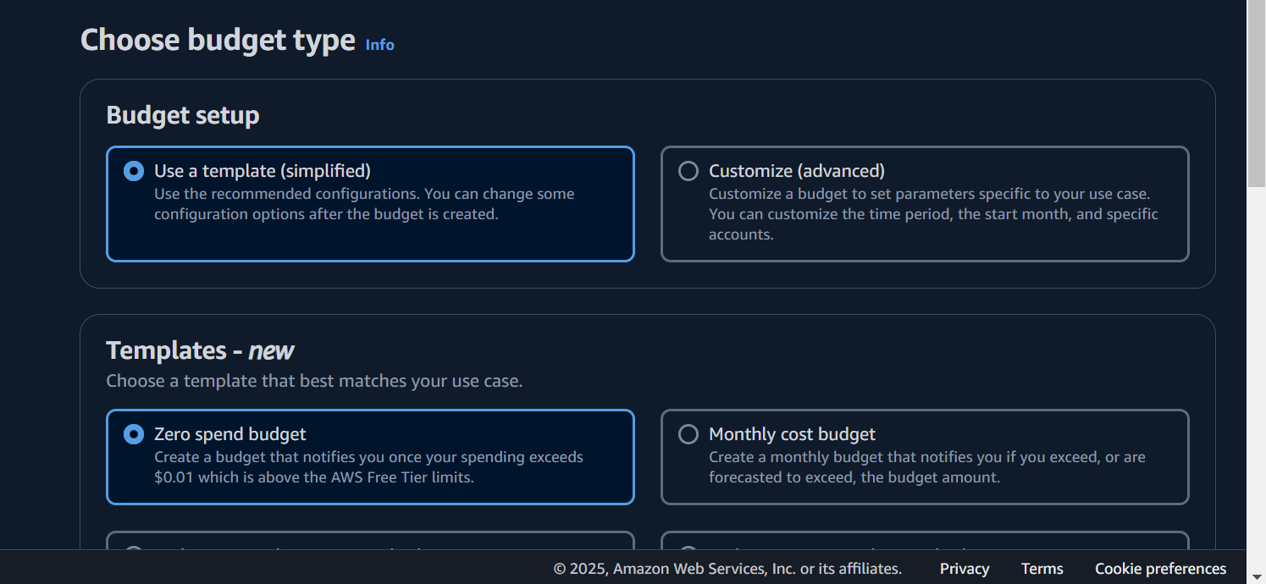

Give the budget a name and provide a email address so we get an email if we incur our first cost on the AWS account.

Congratulations!!! You just configured your first Budget in AWS.

